|  |  |
| --- | --- |
|  | Object Oriented Programming |
| Semester II (Spring 2023)  Course Instructors: Dr Faheem Akhtar, Engr. Asif Ali |

**Department of Computer Science**

|  |
| --- |
| Lab 01**Introduction to Java programming** |

**Objectives:**

1. What is JAVA?
2. Features of Java.
3. JAVA Basics.
4. Installing JDK and setting path.
5. Writing HelloWorld.java in Text Editor
6. JAVA variables & data types.
7. Input & Output
8. Java Variable Type Casting
9. Lab tasks
10. Post Lab Questions

|  |
| --- |
| 1: **What is JAVA?** |

Java was developed by Sun Microsystems in 1995. It is a **programming language**.Java is among the most popular programming languages out there, mainly because of how versatile and compatible it is. Java is general purpose programming language as it is used for software development, mobile applications, web servers, and client-side web applications. It is the native language of the Android operating system, which operates on Android phones and tablets.

Versions of Java

There are many java versions that has been released.

JDK Alpha and Beta (1995)

JAVA 1.0 (23rd Jan, 1996)

JAVA 1.1 (19th Feb, 1997)

JAVA 1.2 (8th Dec, 1998)

JAVA 1.3 (8th May, 2000)

JAVA 1.4 (6th Feb, 2002)

JAVA 5.0 (30th Sep, 2004)

JAVA 6 (11th Dec, 2006)

JAVA 7 (28th July, 2011)

JAVA 8 (18th March, 2014)

JAVA 9 (21th Sep, 2017)

JAVA 10 (20th March, 2018)

JAVA 11 (25th Sep 2018)

JAVA 12 (19th March 2019)

JAVA 13 (17th Sep 2019)

JAVA 14 (17th March 2020)

JAVA 15 (15th Sep 2020)

JAVA 16 (16th March 2021)

JAVA 17 (14th September 2021)

JAVA 18 (22nd, March 2022)

JAVA 19 (20th, September 2022)

**Platform**: Any hardware or software environment in which a program runs, is known as a platform. Since Java has a runtime environment (JRE) and API, it is called a platform.

**Java Platforms**

According to Oracle, there are four platforms of the Java programming language

Java Platform, Standard Edition (Java SE)

Java Platform, Enterprise Edition (Java EE)

Java Platform, Micro Edition (Java ME)

JavaFX/OpenJFX

|  |
| --- |
| 2: **Features of JAVA** |

The following are Java's main features:

* **Object Oriented** − In Java, everything is an object, creating objects that contain data and methods.
* **Architecture-neutral** − Traditionally, we would have to recompile a program for every system that it was going to run on because all systems have a different idea of what their machine code should look like. Java compiler generates an architecture-neutral object file format called as bytecode, which makes the compiled code executable on many machines but with the presence of Java runtime system.
* **Platform Independent** − Unlike many other programming languages including C and C++, when Java is compiled, it is not compiled into platform specific machine, rather into byte code. This byte code is distributed over the web and interpreted by the Virtual Machine (JVM) on whichever platform it is being run on.
* **Portable** − Bytecode can be run by any system in which Java is installed. This is because when java is installed, Java virtual machine is also installed that is specific to that system. It is this machine's responsibility to convert the bytecode into the final instructions of that particular machine.

By making it the system's responsibility to do this final conversion, Java has created a write once, run anywhere language where anyone can hand you a Java program and you can run it on your machine

“Write once, run everywhere”

|  |
| --- |
| 3: **JAVA Basics** |

**JDK**

* 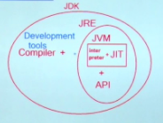It stands for Java Development Kit, is a software development environment used for developing Java applications and applets.
* It compiles and executes new and already built applications.
* It is a collection of development tools as well as Java Runtime Environment (JRE), an interpreter/loader (Java), a compiler (javac), an archiver (jar), a documentation generator (Javadoc) and other tools needed in Java development.

**JRE**

* It stands for Java Runtime Environment. The Java Runtime Environment provides the minimum requirements for executing a Java application.
* It consists of the Java Virtual Machine (JVM), interpreter, JIT, core classes, and supporting files.

**JVM**

* It stands for Virtual Machine (JVM)
* It is responsible for executing bytecode where interpreter provides machine code for the current machine and has JIT as well.

**JIT**

* It stands for Just-in-time Compiler, is the part of the Java Virtual Machine (JVM) that is used to speed up the execution time.
* JIT interpret parts of the bytecode that have similar functionality at the same time, and hence reduces the amount of time needed for full interpretation.

|  |
| --- |
| 4: **Installing JDK and setting path** |

To develop Java applications on our computers, we require a JDK. Visit the link below to download the JDK setup.

<https://download.oracle.com/java/17/latest/jdk-17_windows-x64_bin.exe>

After successful installation, path is to be set which can be temporary through command line or the permanent path which can be set using properties of ‘this PC’, go to advanced system setting and then Environment variable.

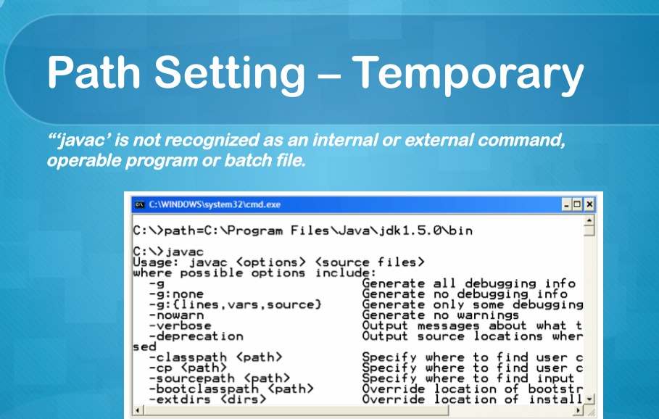

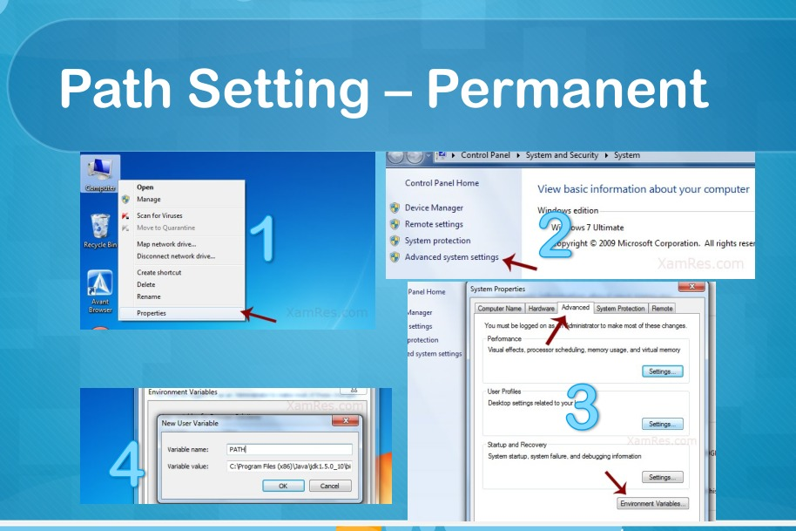

|  |
| --- |
| 5: **Writing HelloWorld.java in Text Editor** |

Follow the below given steps:

1. Run notepad and enter below given code. Save this file with Class name and end it with “.java” extension. Save it on desktop for now!

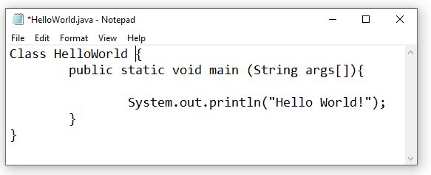

1. Go to search bar in taskbar, write cmd and Open Command Prompt then write the following commands;
   1. cd desktop //for going to desktop
   2. javac HelloWorld.java
   3. java HelloWorld

The Java programming language compiler (javac) takes your source file and translates the code into instructions known as bytecodes. “Java ClassName” will enable Java virtual machine to run your application/code.

|  |
| --- |
| 6: **Variables and data types in JAVA** |

In Java, there are three types of variables:

* Local Variables
* Instance Variables
* Static Variables

**Local Variables**

Local Variables are declared inside the body of a method.

*Scope*: Variables declared inside a method have method level scope and cannot be accessed outside the method

**Instance Variables**

Instance variables are defined without the ‘static’ keyword . They are defined outside a method within a class. Access modifiers can be given for instance variables. They are Object specific.

*Scope*: Dependent on the access modifier

**Class/Static Variables**

It is declared with the keyword ‘static’, outside the method within a class. Static variables are created when the program starts and destroyed when the program stops. There would only be one copy of each static variable per class, regardless of how many objects are created.

*Scope*: Visibility is like instance variables. However, most static variables are declared public since they must be available for users of the class

**Example: Types of Variables in Java**

class Variab {

int InsVarExam = 29; //instance variable

static int IsStatVar = 15; //static variable

void method() {

int IsLocalVar = 90; //local variable

}

}

**Data Types in Java**

Data types classify the different values to be stored in the variable. In java, there are two types of data types:

* Primitive Data Types
* Non-primitive Data Types

**Non primitive** as arrays, strings

**Primitive Data Types**

Primitive Data Types are predefined and available within the Java language. Primitive values do not share state with other primitive values.

There are 8 primitive types: byte, short, int, long, char, float, double, and boolean

**Integer data types**

byte (1 byte)

short (2 bytes)

int (4 bytes)

long (8 bytes)

**Floating Data Type**

float (4 bytes)

double (8 bytes)

**Textual Data Type**

char (2 bytes)

Logical

boolean (1 bit) (true/false)

|  |
| --- |
| 7: **Input & Output** |

**Output in Java Syntax:**

System.out.println("Hello World");

**Input in Java Syntax:**

// import library

import java.util.Scanner;

// Creating scanner object

Scanner ip = new Scanner(System.in); //system.in represents that the input is given via keyboard

Taking input from user

int ipFrmUser = ip.nextInt(); // Integer Input

double ipDbUser = ip.nextDouble(); // Double Input

|  |
| --- |
| 8: **Java Variable Type Casting** |

A variable of one type can receive the value of another type. Here there are 2 cases.

**Case 1**:Variable of smaller capacity is be assigned to another variable of bigger capacity.  
 [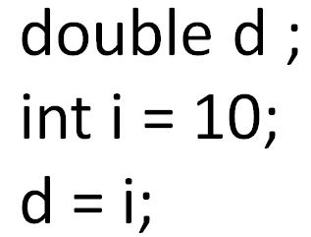](https://www.guru99.com/images/uploads/2012/07/java-type-conversion.jpg)

This process is Automatic, and non-explicit is known as **type conversion**

**Case 2**: Variable of larger capacity is be assigned to another variable of smaller capacity.

[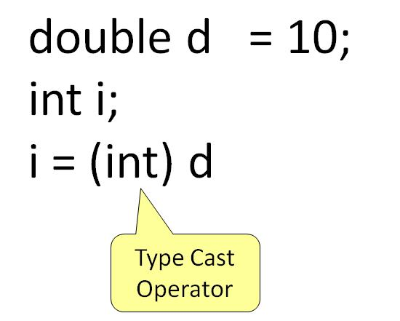](https://www.guru99.com/images/uploads/2012/07/java-type-cast-operator.jpg)

In such cases, you have to explicitly specify the type cast operator. This process is known as **type casting**.  
In case, you do not specify a type cast operator; the compiler gives an error. Since this rule is enforced by the compiler, it makes the programmer aware that the conversion he is about to do may cause some loss in data and prevents accidental losses.  
  
**Example: To Understand Type Casting**

class Demo {

public static void main(String args[]) {

byte x;

int a = 270;

double b = 128.128;

System.out.println("int converted to byte");

x = (byte) a;

System.out.println("a and x " + a + " " + x);

System.out.println("double converted to int");

a = (int) b;

System.out.println("b and a " + b + " " + a);

System.out.println("\ndouble converted to byte");

x = (byte)b;

System.out.println("b and x " + b + " " + x);

}

}

**Output**:

int converted to byte

a and x 270 14

double converted to int

b and a 128.128 128

double converted to byte

b and x 128.128 -128

**Lab Tasks**

Marks : 10, All Questions carry equal marks

**Exercise 1 (JAVA Environment Installation & Error Messages)**

Set up a Java development environment. In the main() method of your program try to compile the following invalid Java code snippets. Record the error messages you receive. What do you think each error message indicates?

System.out.printn(“Hello World”)

System.out.printn(Hello World)

System.out.println”Hello World”;

println(“Hello World);

To generate one final error message, remove one of the brackets from the end of your program. Now what message do you receive?

**Exercise 2 (Mathematical Expressions)**

Write Java code to identify if the given input by the user is even or odd.

**Code Input**

import java.util.Scanner;

class Ex2

{

public static void main(String args[])

{

Scanner ip =new Scanner(System.in);

System.out.print("Enter the any number to check Even or Odd :");

int no=ip.nextInt();

if(no%2==0)

{

System.out.println("The number is Even ");

}

else

{

System.out.println("The number is Odd ");

}

}

}

**Code Output**

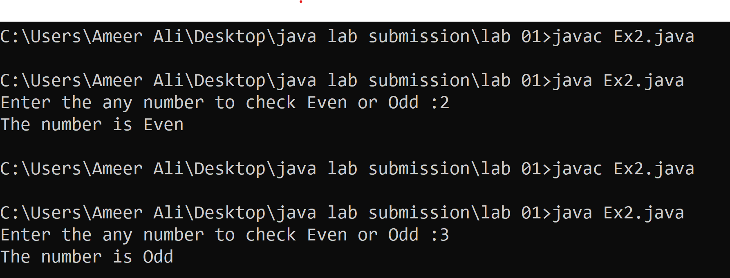

**Exercise 3 (Type casting)**

Perform division using two double variables and store the result in int variable and print the results

**Code Input**

class Ex3

{

public static void main(String args[])

{

double a,b;

a=10;

b=5;

int c,d;

c=(int)a;//when we convert double to int otherwise only we assign.

d=(int)b;

System.out.println("The division of C/d is "+(c/d));

}

}

**Code Output**

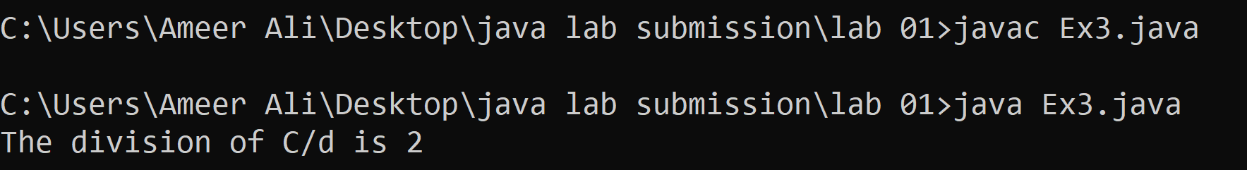

**Exercise 4 (Operators)**

Find largest among three numbers using if..else as well as operators statement

Enter value a:30

Enter value b:10

Enter value c:70

**Code Input**

import java.util.Scanner;

class Ex4

{

public static void main(String args[])

{

Scanner ip=new Scanner (System.in);

System.out.print("Enter the first number :");

int a=ip.nextInt();

System.out.print("Enter the Second number :");

int b=ip.nextInt();

System.out.print("Enter the Third number :");

int c=ip.nextInt();

if((a>b)&&(a>c))

{

System.out.print("The greater value is "+a);

}

else if((b>a)&&(b>c))

{

System.out.print("The greater value is "+b);

}

else if((c>a)&&(c>b))

{

System.out.print("The greater value is "+c);

}

}

}

**Code Output**

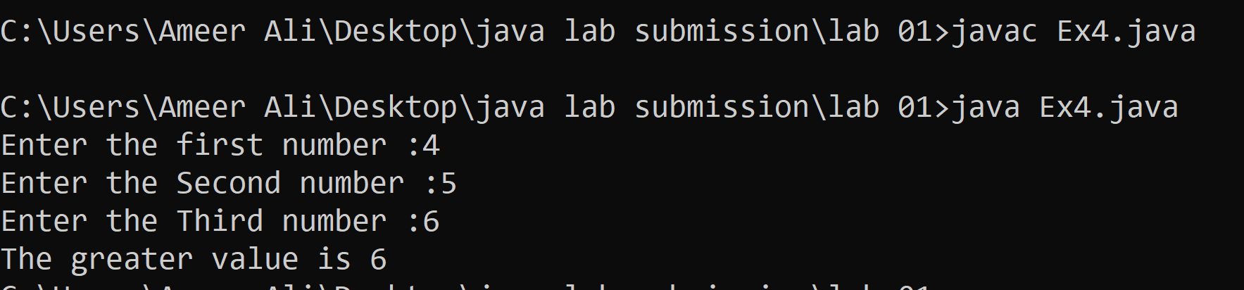

|  |
| --- |
| **Post lab questions to ponder** |

1. Can you cast string into int?
2. Why JAVA when there are other OOP languages?